Little SPARK: Simple Play Adaptations to Reference for Kids

Buddy Button Switch
Description: | Image:
The Buddy Button is a mechanical wired single switch that requires only the slightest touch of its 2.5-in/6.4-cm surface for activation. | 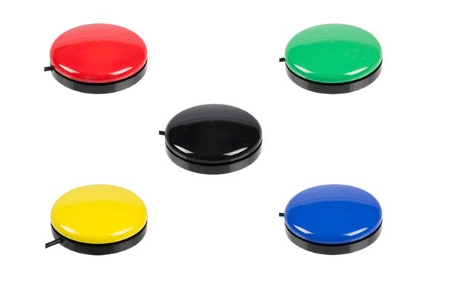

Who Might Benefit?
Those who have motor challenges and need an alternate form of access to engage in activities like adapted toys, speech generating devices, and other battery/electronic devices.
Why Use?
Provides an opportunity to access and engage in typical childhood activities through adapted electronic means that are not accessible in the usual way to the child.
Instructions for Use: | Adaptation Ideas:
Environmental Considerations  - Used in most environments; avoid water, dirt and sand.  Positioning & Alternate Positioning  - Place on a flat surface or velcro onto any surface where it can be securely attached and can be activated without moving away from the child.  - Could be attached to a mounted arm or other switch mounting system.  Basic Play/Use  - Plug directly into the switch port of the device with the switch jack.  Extended Play/Use  - Various attachments are available to adjust features of the switch, check out the OCALI Lending Library for more.  Play/Use with Others  - Multiple switches can allow multiple players to do various parts of an activity.  Words to Encourage Play/Use  - These words would be primarily dependent on the activity the switch is activating. Switch function words could be helpful as they start learning about the switch. | Build It Up  - Put the switch inside a 3-ring binder to add a bigger surface to activate.  Stabilize It  - Use Velcro to stabilize to the table or floor.  Add Sensory Cues  - Add different textures, change the switch button color, or add picture symbols to indicate a specific action/activity.  Alternative Uses  - Use different types of switches and trial until finding the right fit for the child/activity.

